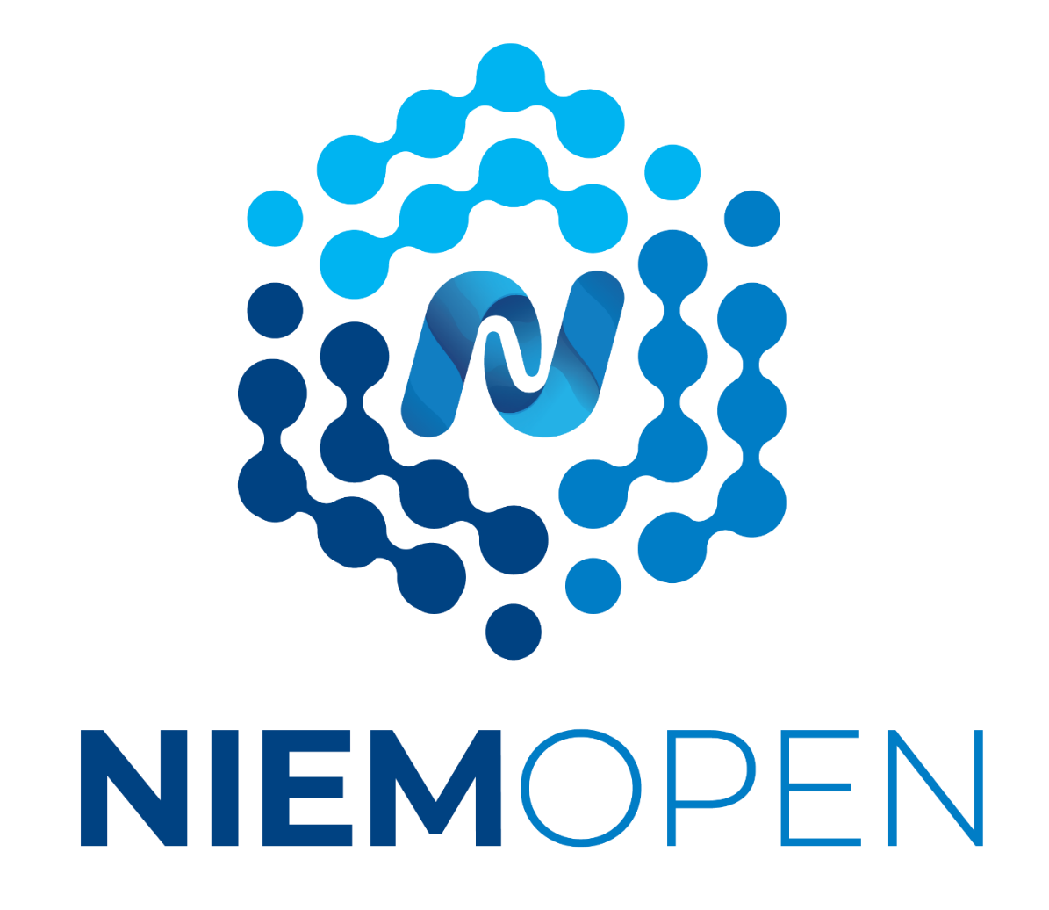

Book of NIEM

*23 July 2025*

Contents

1 Executive Summary ii

2 What IS NIEMOpen? 1

2.1 The NIEMOpen Organization 2

2.2 The NIEMOpen Community 2

2.3 The NIEM Model 3

2.4 Naming and Design Rule Specification 4

2.5 Common Model Format (CMF) Specification 4

2.6 Tools 5

2.6.1 CMF Tool 5

2.6.2 API 2.0 Tool 5

3 NIEMOpen Value Proposition? 5

4 Who Uses NIEMOpen? 6

5 Implementations 7

5.1 Domain Implementation Highlights (Table) 8

5.2 International Implementations Highlights (Table) 9

6 Focus on DoD MilOps 11

6.1 Policy 11

6.2 NIEMOpen Sample of DOD Implementations (Table) 12

7 Focus on NIEMOpen & NATO 16

8 State, Local, Tribal, Territorial (SLTT) Implementations 16

8.1 SLTT Implementations (Table) 17

9 NIEMOpen ROI 35

10 Executive Orders, Laws, Policies, & Standards 35

10.1 Executive Orders 35

10.2 Laws and Statutes 36

10.3 Policies and Standards 36

10.3.1 DoD Information Sharing Policy & Guidance 36

10.3.2 Tactical Edge Interoperability & Standards Using NIEMOpen 37

10.3.3 Data Management Book of Knowledge (DMBOK) Reference 38

11 Summary 39

12 Acronyms 1

13 Endnotes 3

# Executive Summary

**Open Standards** play a crucial role in the digital economy by fostering interoperability, innovation, and competition across various sectors. The absence of U.S. leadership in establishing these standards allows other nations, such as China and Russia, to set global norms. This lack of strategic vision and investment hampers national security and economic competitiveness, as open standards are essential for enhancing decision-making, reducing errors, and maintaining public trust. The **NIEMOpen** initiative, now under the Organization for the Advancement of Information Standards (OASIS), exemplifies the importance of open standards by providing a standardized approach to data exchange that can bolster emerging technologies including artificial intelligence (AI) and cybersecurity efforts.

NIEMOpen has evolved from the National Information Exchange Model, focusing on creating a common framework for data sharing among diverse communities. The NIEMOpen open-source project emphasizes community interaction, a robust technical framework, and a supportive governance structure to facilitate the development of Message Exchange Packages (MEPs). These packages enable various organizations and specifically the Department of Defense and Department of Homeland Security to implement consistent data exchange protocols, which are vital for effective communication, data exchange and collaboration in areas like national security, southwest boarder security, NATO-NATO Core Date Framework, mission partner environment interoperability, AI, Joint C5I, biometrics, DoD forensics, cybersecurity and a host of interagency, state, local, tribal and industry initiatives. By standardizing data formats and definitions, NIEMOpen ensures that systems (machine-to-machine) as well as humans can understand and interpret information accurately, regardless of their origins.

In conclusion, the transition of NIEM to NIEMOpen under OASIS signifies a key advancement in establishing open standards for data interoperability. This initiative not only reduces costs and enhances the efficiency of information sharing across governmental and private sectors but also positions the U.S. to assert its leadership in global standard-setting. As NIEMOpen continues to grow, its emphasis on community-driven, mission partner development and adherence to established standards will pave the way for improved data sharing, facilitating trust and collaboration in critical areas such as AI and cybersecurity.

# What IS NIEMOpen?

NIEM Open Project’s (NIEMOpen) evolution traces back to 2003 to the Global Justice XML Data Model (GJXDM) initiative and the standup of the Department of Homeland Security (DHS) - [NIEM’s History | NIEM Open](https://niemopen.org/about/history/) .

This nascent grassroots effort by Justice and DHS to create common, well defined data elements, semantics, and syntax for data exchange between diverse communities of interest culminated in the formal instantiation of the National Information Exchange Model (NIEM) in April 2005 - [How NIEM Got Started - YouTube](https://www.youtube.com/watch?v=1Syaq9PU_Sw) .

NIEM entomology - NIEM no longer is an acronym for the National Information Exchange Model but is simply the brand when referring to NIEM Open Project architecture, data model, technical infrastructure, and domain spaces attributable to the former descriptive business name NIEM. Industry is replete with similar synthetic business names such as 3M, Sony, Google among others. Today, NIEMOpen refers to the organization, business operations, functions , and data standard of NIEM Open Project under the auspices of the Organization for the Advancement of Information Standards (OASIS) Open Projects Program, OASIS OPEN - [Open Projects Program - OASIS Open](https://www.oasis-open.org/open-projects/) . NIEMOpen is an open-source project that manages the data standard branded NIEM.

The NIEMOpen program is a community-driven, government-wide, standards-based approach to exchanging information. Diverse communities can collectively leverage NIEMOpen to increase efficiencies and improve decision making. There are three different aspects to the value of NIEM:

* Community interaction,
* Technical framework that helps define data structures, and
* Support framework that helps from an implementation perspective.

NIEMOpen is described as a framework, because it is not just a Reference Architecture that provides a common data vocabulary for information exchanges, it includes several components to enable implementation and achieve interoperability:

* A common data model called NIEM core that provides data components for describing universal objects such as people, locations, activities, and organizations More specialized business focused data models for more specialized use cases, called domains (examples including Cyber, Justice, Immigration, and Emergency Management)

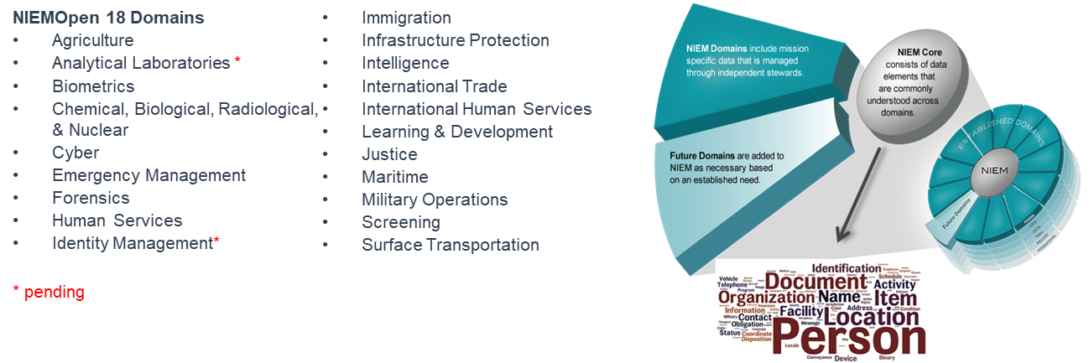

* A methodology for using and extending the building blocks that come from the common and domain-specific models to turn them into complete information exchanges, known as an formerly Information Exchange Package Documentation (IEPD) or current usage,Message Exchange Package (MEP)
* Tools to help develop, validate, document, and share the information exchange packages
* A governance organization that provides training and support and oversees NIEM's evolution over time

NIEMOpen is available to everyone. The NIEMOpen community spans federal, state, local, tribal, international, and private sector entities. It is this diverse group of people who drive NIEMOpen forward. NIEMOpen was built by the community for the community.

## The NIEMOpen Organization

For the first 17 years of the National Information Exchange Model program, overall program governance resided in the Executive Steering Council (ESC). Originally, ESC membership included the Department of Justice (DoJ), and DHS. The Department of Human Services (HHS) Joined in 2009, and the Department of Defense adopted NIEM in 2013, establishing the Military Operations Domain. This corresponded to establishment of DoD’s “NIEM first” policy which was signed by Teri Takai (DoD CIO) in 2013.

The Chair of the ESC eventually rotated among these 4 principals – DoJ, DHS, HHS, and DoD. In September 2021, the NIEM ESC approved the transition of NIEM to the Organization for the Advancement of Structured Information Standards (OASIS) and J. Clark Cully ( DoD Deputy, Chief Data Officer) sunset the NIEM ESC on 20 October 2022 – [Cully Sunset Memo](https://github.com/niemopen/nbac-admin/blob/main/niem-book/Transition%20of%20the%20National%20Information%20Exchange%20Model%20to%20the%20Organization%20for%20the%20Advancement%20of%20Structured%20Information%20Standards%20Open%20Project%20Prog.pdf).

Whereas there were multiple reasons for this transition, having NIEM a part of OASIS Open Project provided a clear path for NIEMOpen to become an accredited open-source standard with the *Bonafide* of a respected non-profit standards body. A description of OASIS core services, lightweight rules, and licenses are found at <https://www.oasis-open.org/open-projects/> . In addition to becoming an OASIS Standard (OS), OASIS provides the opportunity to get American National Standards Institute (ANSI) and International Organization for Standardization (ISO) approval.

The current NIEMOpen organization consists of the **Project Governing Board (PGB) and 3 Technical Steering Committees (TSCs):**

* NIEMOpen Management Office (NMO) TSC
* NIEMOpen Technical Architecture Committee (NTAC) TSC
* NIEM Open Business Architecture Committee (NBAC) TSC.

Open Projects are funded by sponsorship, grants, and donations and each sponsor is afforded a seat on the PGB. As of July 2025, there are 11 active sponsor voting members as well as 1 expert voting member from each TSC. Each of the active NIEMOpen domains are represented by a sub-committee under the NBAC or if inactive, under conservatorship of the NBAC. It is not uncommon for domain space sub-committees to migrate between active participation and a more passive posture as their need for new content and exchanges ebbs and flows over time.

Details of roles and responsibilities, governance, committees, specifications, resources, and tools as well as a directory of NIEMOpen GitHub repositories are found at <https://github.com/niemopen/> and OASIS lightweight Rules <https://www.oasis-open.org/policies-guidelines/open-projects-process/> .

## The NIEMOpen Community

The NIEMOpen Community consists of the OASIS Project Administrator, project sponsors, PGB, and NBAC, NTAC and NMOTSCs, sub-committee members, maintainers, contributors ,OASIS members, and guests - <https://www.oasis-open.org/policies-guidelines/open-projects-process/> .

## The NIEM Model

The NIEM model, and likewise the NIEMOpen community, spans diverse mission spaces across government, industry, Non-Governmental Organizations (NGO), Private Voluntary Organizations (PVO), academia, and international organizations. Currently, the NIEM model includes 18 domains including: Agriculture, Biometrics; Chemical, Biological, Radiological and Nuclear; Cyber; Emergency Management; Immigration; Human Services (Children, Youth and Family Services); Infrastructure Protection; Intelligence; International Human Services, International Trade; Justice; Learning & Development; Maritime; Military Operations, Screening; Surface Transportation; and most recently Forensics. It’s likely that you may find your organization’s mission space within one or more of these 18 domains.

NIEMOpen domains represent both the governance (Domain Space Sub-Committee) and model content oriented around a community’s business needs. NIEMOpen domain space sub-committees manage their portion of the NIEM data model while working with other NIEM domains to collaboratively identify areas of overlapping interest. Future domains are added to NIEMOpen and the NIEM model as necessary, based on an established business need.

The current version of the NIEM model, NIEM Model version 6.0 PS02 specification was approved by the PGB in May 2025 and posted in the OASIS Library. The authoritative version along with zip files of previous releases are available on the NIEM GitHub repo: <https://github.com/niemopen/niem-model> .

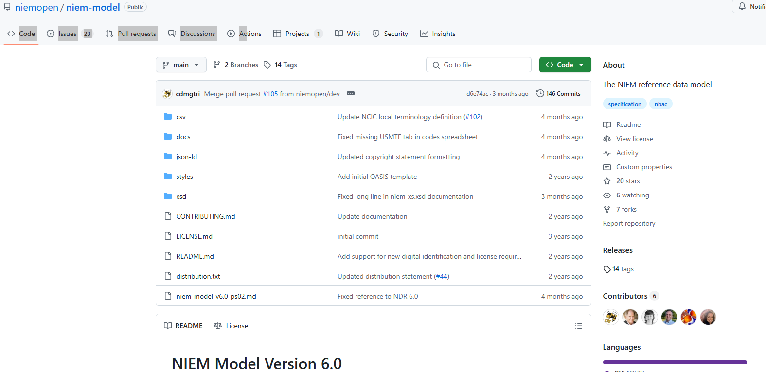

On the left panel of the model repo, click My tags to access previous releases: <https://github.com/niemopen/niem-model/tags>

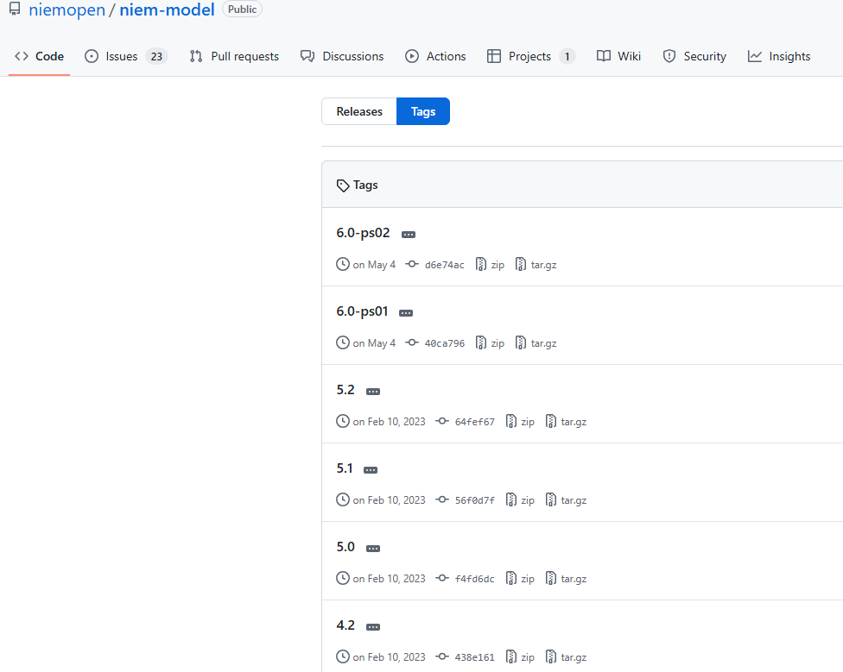

## Naming and Design Rule Specification

A companion specification to the model is the NIEM Naming and Design Rules (NDR). A draft NDR version (PSD01) aligned with NIEM Model Version 6.0 is approved by the PGB and is currently under review for approval as a specification and publication to the library: <https://github.com/niemopen/niem-naming-design-rules> .

## Common Model Format (CMF) Specification

NIEMOpen Common Model Format Specification (CMF) CMF is a NIEM message specification for data models.

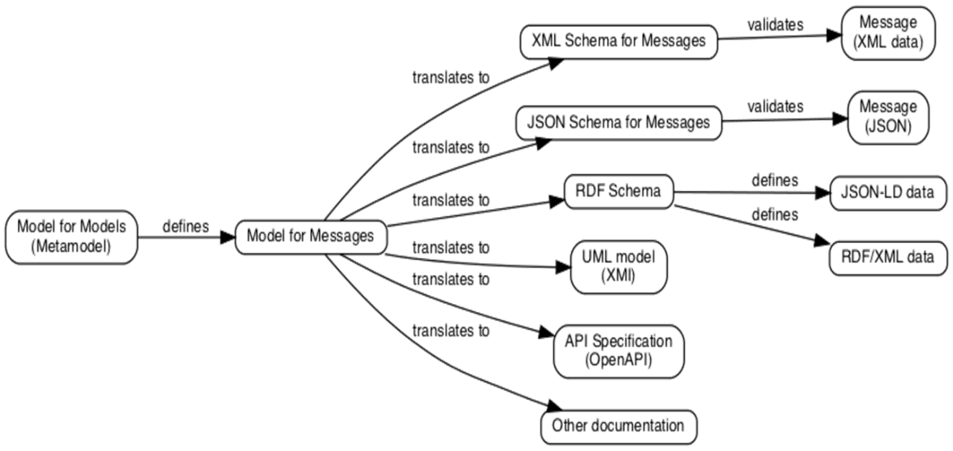

In all versions of NIEM through version 5, data models are expressed in XML Schema Definition (XSD[1]). CMF offers an equivalent expression, one that is more suitable for developers not working in XML and is easier to support with developer tools. Using CMF, a data model can be expressed as XML, RDF[2], and JSON/JSON-LD[3] or any other data serialization that NIEM supports, and the data described by the CMF data model can also be expressed in any supported serialization: <https://github.com/niemopen/common-model-format>

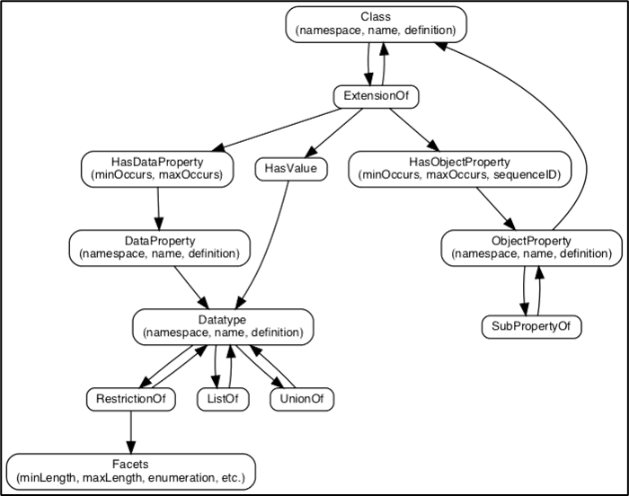

A data model for NIEMOpen data models is a NIEMOpen metamodel. It defines a class of data objects that describe the NIEMOpen data models (a "model description" data object). It represents the aspects of the NIEMOpen model that we care about, without a focus on XML Schema-specific features.

A data component has a name, namespace, and a human-readable definition:

* + A Class defines a category of object. e.g., a vehicle
  + A Datatype defines a category of simple data: e.g., a string, date, or enumeration
  + An Object Property represents a relationship to an object
  + A Data Property represents a characteristic with simple data values

## Tools

The NIEMOpen Community has developed tools to assist with:

* + Information exchange [Message Exchange Package (MEP) formerly referred to as an Information Exchange Package Documentation (IEPD)] development
    - A MEP/IEPD is a collection of NIEM artifacts that define and describe the context, content, semantics, and structure of one or more implementable information exchanges.
  + Model management​
  + Model search and discovery
  + Information exchange storage, search, and discovery
    - The MEP Registry and Repository can be accessed at <https://www.niem.gov/about-niem/message-exchange-package-mep-registry-repository>

The tools catalogue is available at <https://www.niem.gov/tools-catalog> . Two recent toll initiatives include the Common Model Format (CMF) tool and API 2.0.

### CMF Tool

The NIEM [*Common Model Format (CMF)*](https://github.com/niemopen/common-model-format) is a data modeling formalism for NIEM-conforming data exchange specifications. CMFTool is a command-line tool for the designers of those specifications.

### API 2.0 Tool

[API 2.0](https://github.com/niemopen/niem-api/tree/dev) is a Java Spring Boot REST API and backend implementation for NIEM tool functionality. It includes support for NIEM and NIEM-based community models, search, transformations, NIEM subset migrations, and validation.

* It will replace the functionality of legacy tools:
* SSGT <https://tools.niem.gov/niemtools/ssgt/index.iepd>
* ConTesA <https://tools.niem.gov/contesa/>
* Migration Assistance <https://tools.niem.gov/niemtools/migration/index.iepd> .
* Support future NIEM model management
* Maintain legacy support for older NIEM versions, and
* Support multiple serializations of NIEM.

# NIEMOpen Value Proposition?

The data sharing dilemma:

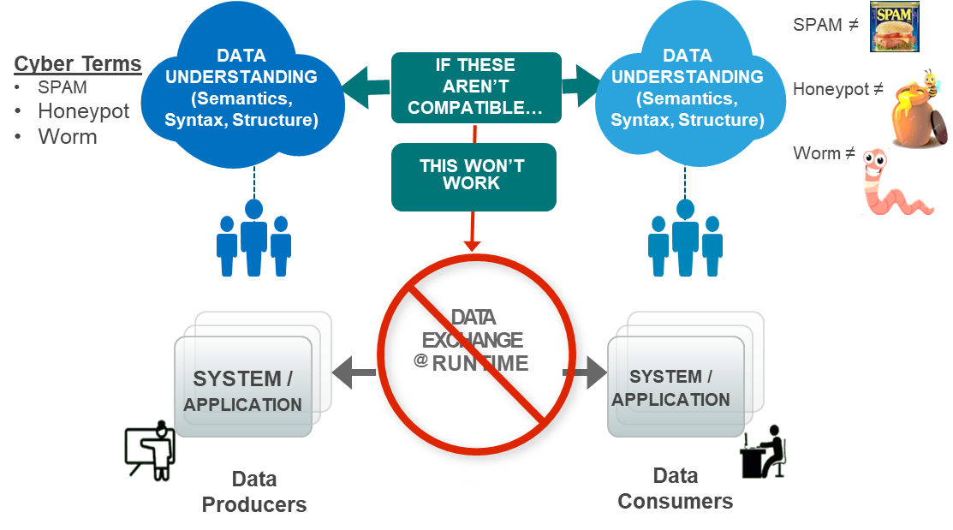

Ensuring all partners of an exchange can understand each other is critical to mission success.

In this picture, the data interoperability challenge is to ensure that the different systems have a compatible understanding of the data to be exchanged – because if the systems on the left have a different understanding than the systems on the right, then something will be broken, and someone will be unhappy.

Although the graphical comparisons are laughable to a human; computers cannot discern the meaning of one string (e.g., worm vs. worm) from the other unless humans program them to. A computer program designed to recognize a standalone malware worm is not likely to understand a worm insect.

They are spelled the same but have different context.

This is the idea behind NIEM—letting your system and my system speak—even if they've never spoken before. NIEMOpen ensures that information is well-understood and carries the same consistent meaning across various communities, allowing interoperability to occur.”

For machine-to-machine data interoperability, there are software developers who build applications on behalf of producers and consumers. They work from an message exchange package, a build-time description of the data to be exchanged at runtime. If they do their jobs right, then the data produced at one side will be properly interpreted at the other, and everyone will be happy.

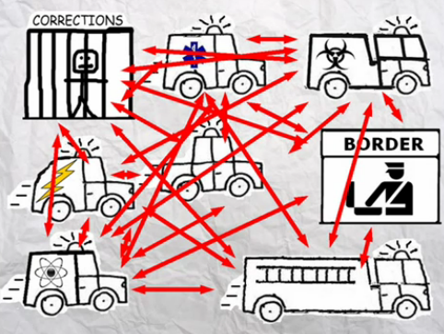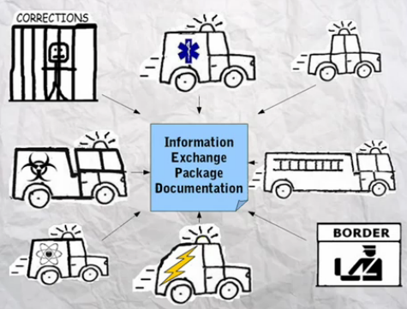

EXAMPLE Communicating With 15 Different Systems N(2) Problem

Without NIEM

With NIEM

This cartoon depicts a tenant of the NIEMOpen advantage. When using NIEM, you only need to “speak” two languages — your own and NIEM.

For over 20 years, the National Information Exchange Model(NIEM) has been a foundational basis for information sharing within and across domains and communities of interest. Federal, state, and local agencies and other countries have leveraged the harmonization of the 20,000+ data elements in the model and the methodology for developing message specifications based on the NIEM Naming and Design Rules. Having transitioned to NIEMOpen, we have reached a new milestone in its evolution.  As a project operating under the auspices of OASIS, we have access to and support from the long-standing and proven OASIS methodology for establishing and supporting standards. To that end, we will be establishing the NIEMOpen platform as an OASIS Standard, ultimately as an ANSI standard, or possibly an ISO standard.

Achieving this advanced level of NIEMOpen can promulgate not only individual message exchange standards but also APIs that form the foundation of data structures, vastly increasing the potential for improving information sharing within organizations and beyond to all connected partners.   Several new developments along these lines were recently described in the latest release of NIEMOpen during [the 22 May 2025 IJIS hosted webinar](https://www.youtube.com/watch?v=pP3qDd23sx4&t=2s) – The New NIEMOpen .

# Who Uses NIEMOpen?

Over the coarse of 20 years a broad spectrum of communities have embraced the the NIEM data model and methodology. Our previous dicsussion identified 18 domains and associated COIs that formally are part of NIEMOpen (Domain Space Sub-Committees). A brief summary of domains and their associated sub-committees are found at - <https://niemopen.org/community/> . Additionally, two new prospective domains, Identity Management and Analytical Laboritories, are on the cusp of onboarding. Analytical Laboatories is the NIEMOpen COI representing the Integrated Consortium of Laboratory Networks (ICLN) – <https://www.icln.org/> .

It is difficult to account for all the organizations that have used NIEM and created MEPS/IEPDs since NIEM/NIEMOpen is a voluntary open source standard without compulsory registration of products developed. Under NIEMOpen as an OASIS Open Project, only formal contributions require an entity or individual license agreement identifying the individual or organization contributor. Similarly, contributing to the MEP repository is voluntary.

A abridged snapshot of some contemporary Federal customers/products using NIEM/NIEMOpen would include:

* **Federal Government**
  + US Air Force – Cursor on Target (CoT)​
  + US Army – Tactical Infrastructure Enterprise Services (TIES)​
  + US Navy – Maritime Information Sharing Environment​
  + Special Operations Forces (SOF)​
  + Joint Non-kinetic Effects (JNKE)​
  + Tactical Service Oriented Architecture (TSOA)​
  + Warfighter Mission Area Architecture Federation and Integration Portal (WMA AFIP)​
  + MIL-STD 6016 (Link-16, TDL)​
  + MIL-STD 6017 (VMF, XML)​
  + MIL-STD 6040 (USMTF)​
  + NATO- NATO Core Data framework
  + NORAD/NORTHCOM – Situational Awareness Geospatial Enterprise (SAGE)​
  + FBI – Incident Reporting National Data Exchange System (N-DEX)​
  + FBI – National Crime Information Center (NCIC)​
  + FEMA – National Incident Management System (NIMS)​
  + CDC – Emergency Preparedness & Response Exchange Requirements​

We will further explore users and implementations in subsequent sections of this document.

# Implementations

**NIEMOpen Implementations Worldwide**

NIEMOpen is unique as an open-source, multi-information domain development and implementation framework. It provides a common vocabulary and structure for sharing data across organizations. NIEMOpen has been adopted in numerous large-scale government information systems, private-sector solutions, and data governance efforts globally. Notable implementations include:

* **Law Enforcement / Criminal Justice**: The FBI’s **National Data Exchange (N-DEx)** program aggregates criminal justice records nationwide. Participating agencies map incident reports, arrest records, citations, etc. into XML using NIEM (and LEXS) standards. N-DEx “connects the dots” by automatically correlating NIEM-formatted data across jurisdictions. Similarly, the Florida Dept. of Law Enforcement’s **CJIS Division** adopted a NIEM XML schema for statewide crime reporting; this standardized, uniform format instantly delivers validated data to state and federal partners, significantly reducing reporting burdens.
* **Immigration and Social Services**: U.S. Citizenship and Immigration Services (**USCIS**) used NIEM to harmonize and migrate data across legacy systems. By embedding NIEM structures in a new Salesforce CRM, USCIS consolidated 55+ attribute definitions and streamlined data mapping for programs like e-Verify/SAVE. In Canada, **Employment and Social Development Canada (ESDC)** adopted NIEM for social program data. ESDC’s projects (e.g. accounts receivable and contact-center systems) use NIEM-based exchanges to enforce consistent definitions and high-volume interoperability with partner agencies.
* **Defense and Security**: The U.S. Department of Defense’s **DCSA** (Defense Counterintelligence and Security Agency) published a NIEM-conformant IEPD for the DD‑254 contract security classification form. The DD‑254 semantics were embedded in NIEM 4.1 and exchanged in XML/JSON format, enabling standardized dissemination of security requirements across the defense, federal, and cleared contractor communities. NIEM is also identified as a data standard in the Combined Joint All-Domain Command and Control (CJADC2) reference architecture (DoD’s networked defense framework). NIEM’s use in these projects ensures a **common semantic foundation** for classified data and multi-agency defense information sharing.
* **Data Governance / Enterprise Architecture**: NIEM’s value extends beyond message formats into **data governance and enterprise modeling**. For example, the Virginia Office of Data Governance and Analytics (ODGA) launched the **Commonwealth Data Trust**, an inter-agency data-sharing environment that “reduces technical costs by onboarding to a single environment using standard NIEM protocols”. By using NIEM as a core data dictionary, Virginia agencies share data under consistent rules and formats. Likewise, NIEM has been used in policy development: Florida’s CJIS leverages NIEM to ensure data quality and to “play a major role in policy development for national sharing of criminal justice information”. In the private sector, companies like InfoStrat embed NIEM in enterprise solutions (e.g. Microsoft Dynamics 365); NIEM serves as a *reference model* that “helps software architects standardize their data definitions” in justice/public safety case-management software.
* **Regional and International Projects**: At the city and state level, NIEM enables cross-jurisdictional sharing. Charlotte (NC) integrated its police data with the U.S. Naval Criminal Investigative Service’s LInX exchange and North Carolina’s NIBRS crime-reporting system by adopting NIEM IEPDs (the FBI’s N-DEx schema). Internationally, NIEM is recognized as a model for interoperability: communities in Europe, North America, and Australia “already use NIEM for their information exchange efforts”. For instance, the Canadian federal government (see ESDC above) and the Australian National Archives cite NIEM as a standard for consistent data meaning.

The tables below summarize exemplary NIEM-based implementations:

## Domain Implementation Highlights (Table)

|  |  |  |
| --- | --- | --- |
| Domain | Agency | Description |
| MilOps | Department of Defense (DoD)  Joint Staff J6 stewards on behalf of the DoD CIO | Data components necessary to support improved data interoperability between DoD and mission partners for operations. |
| US Army | DHA, MIM/MIP prospective |
| US Air Force |  |
| US Special Operations Command |  |
| US Navy | Support full Maritime Domain Awareness: "the effective understanding of anything associated with the global maritime domain that could impact the United States’ security, safety, economy, or environment" including vessels, people, cargo, maritime locations and activities. |
| Office of Naval Intelligence (ONI) OCIO stewards in coordination with DHS |  |
| Defense Logistics Agency |  |
| Biometrics | DHS National Protection and Programs Directorate (NPPD) Office of Biometric Identity Management (OBIM) | Part of a coordinated global effort to maintain and refine operations focused on security, intelligence, law enforcement, international trade, travel and immigration by means of identity management and assurance |
| Emergency Management | DHS Science and Technology (S&T) First Responders Group (FRG) | Supports emergency-related services (first responders, responding to disasters), information sharing, and activities such as homeland security and resource communications management |
| Immigration | DHS Citizenship and Immigration Services (CIS) and Immigration and Customs Enforcement (ICE) | Standardized information sharing to improve investigative and enforcement responsibilities for federal immigration laws, customs laws, and air security laws to foster better collaboration with their external partners |
| Screening | DHS Citizenship and Immigration Services (CIS) and Immigration and Customs Enforcement (ICE) | Supports, coordinates, and harmonizes a wide range of screening and credentialing activity information across homeland security mission areas |
| Chemical, Biological, Radiological, and Nuclear (CBRN) | DHS Domestic Nuclear Detection Office (DNDO) with cooperation of Customs and Border Patrol (CBP) | National effort to detect and interdict radiological and nuclear threats. The GNDA (Global Nuclear Detection Architecture) involves DHS, DOJ, DOE, DOS, DOD, the Governmental Nuclear Regulatory Commission (NRC), state, local, and tribal agencies |
| International Trade | DHS Customs and Border Protection (CBP) | Enable relevant government agencies to exchange and share information, resulting in greater facilitation of trade and more effective identification and elimination of security threats before they arrive at ports and borders. Aligns with the World Customs Organization (WCO) Data Model and the Customs Business Process models. |
| Infrastructure Protection (IP) | DHS Office of Infrastructure Protection ​(IP) | Coordinated national program to reduce risks to the nation's critical infrastructure and key resources (CIKR) |

## International Implementations Highlights (Table)

|  |  |
| --- | --- |
| Country | Description |
| Mexico | U.S. Customs & Border Protection’s (CBP) Global Enrollment System (GES) web service is used by Mexico, according to a NIEM International Tiger Team report. |
| South Korea |
| US, Canada, Mexico | **Public Safety Pilot**: The goal of this pilot project was to test exchanges of stolen vehicle information among the U.S., Canada, and Mexico using NIEM. The trilateral working group conducted a technical demonstration and exchange between the U.S. and Canada. We expect exchanges with Mexico to be completed soon. [2012]  https://wiki.nlets.org/index.php/Section_33:_Communicating_with_Mexico  NLETS - Mexican Commercial Drivers license  Mexico Commercial License Plate File  July 14, 2011 Agreement |
| US, Canada, Mexico | **Public Health Pilot**: This pilot project’s goal was to test an exchange of aggregated public health alerts for food-borne infectious diseases between the U.S., Canada, and Mexico using NIEM. The working group attempted to demonstrate an exchange of real-time, aggregated public health alerts among the three countries. They documented their processes and lessons learned for future exchanges of this type for the public health community and planned to share the NIEM IEPD with the World Health Organization. The working group started to outline a roadmap for moving from a pilot/test environment to full production. [2012] |
| Canada | [2007/08] The Information Sharing Environment Suspicious Activity Report (ISE-SAR) Functional Standard was implemented in Canada using the SAR IEPD to enable improved information sharing with public safety operations. (NOTE: According to information Thomas Krul sent, this was a pilot project.) |
| Canada | Trusted Information Exchange System (TIES) |
| Canada | According to Thomas Krul, NIEM compatibility is "baked into": * Canada's Offender management system * The RCMP's Canadian Police Information Centre * Fisheries and Oceans Canada’s Oceans Protection Plan |
| Canada | The Entry/Exit Information System (EXIS) is the IT component of the Entry/Exit initiative which includes a new bi-directional information exchange between the CBSA and CBP to share biographical information on travelers in the land mode. |
| Canada | ESDC interoperability team began using NIEM as its enterprise information exchange model in November 2017  * Interoperability solutions have been developed in the following areas: - Finance - Human Resources - Labour/Employment - Immigration - Case Management - Document Management - Interactive Voice Response  * Interoperability partners: - Federal government departments - Provinces, Territories and First Nations, Inuit and Métis communities - Employers |
| Canada | The **Temporary Resident Biometrics Project** (**TRBP**) was delivered through a partnership of three Canadian government departments and the United States Citizenship and Immigration Services (USCIS). The solution includes a collection system, a processing engine to provide workflow and act as the information exchange platform between partner systems, and a standardized interface to receive biometrics from other governments. The use of NIEM shortened delivery time, reduced cost, and aided real-time data exchange and enhanced interoperability. Overall, the solution greatly enhanced identify management capabilities for the processing of Canadian visa applications and screening of foreign nationals at Canadian borders.  https://www.publicsafety.gc.ca/cnt/rsrcs/pblctns/rprt-plns-prrts-2013-14/index-en.aspx |
| Canada | NIEM has been endorsed by: - Canadian Association of Chiefs of Police (CACP)  – Government of Canada’s Interoperability Framework  – Part of CBSA’s Enterprise Architecture Information Sharing vision  – Transport Canada  – Part of the Interdepartmental Marine Security Working Group (IMSWG work plan  – Part of the CAN-US Communications Interoperability Working Group (CIWG) priorities |
| Canada | According to Thomas Krul, the Department of National Defence is interested in seeing how DoD implements NIEM and is paying close attention to NATO CWIX. |
| Australia | According to CrimTrac's 2016 annual report, the agency had developed and implemented the National Child Offender System Data Provision Service and was in the process of developing the Bulk Export Consumption Service, both of which used NIEM conventions to facilitate data exchange. |
| Sweden | The Information Sharing Environment Suspicious Activity Report (ISE-SAR) Functional Standard was implemented in Sweden using the SAR IEPD to enable improved information sharing with public safety operations. |
| 5CC / FVEY (US, Australia, New Zealand, Canada, UK) | According to an email sent by Kamran Atri, in 2013, a briefing "was requested by the Five Countries Conference, or 5CC, (US, Australia, New Zealand, Canada and UK) representatives to understand the power of unified information exchange structure and showcase how a standardized data exchange would work between the 5 countries. I actually developed a NIEM data exchange IEPD and a set of coded GUIs to actually show (live) what happens when an Web form is populated and how NIEM will be in use and how the data exchange works from the front end and the back-end (code). This was well received and the 5CC (or 5i as they are called in DoD) started developing their exchanges this way." |
| NATO | NATO Core Data Framework uses NIEM’s framework and data model. |

# Focus on DoD MilOps

## Policy

By direction of the Joint Staff (JS) J6 (JSM 12 April 2013 Subject: DoD Adoption of the National Information Exchange Model (NIEM) and Establishment of the NIEM Military Operations Domain and JSM 5100.01F "Organization and Functions of the Joint Staff"), a Military Operations (MilOps) Domain within NIEM (National Information Exchange Model) was established in 2013. It is supported by the Department of Defense (DoDI 8320.07 3 August 2015 Subject: Implementing the Sharing of Data, Information, and Information Technology (IT) Services in the Department of Defense) which states that states NIEM should be considered first when deciding on an information sharing exchange. The MilOps Domain was established to achieve digital military operations interoperability across DoD and Mission Partners.

In November 2023, the NIEM framework and data model transitioned to an open project under the Organization for the Advancement of Structured Information Standards (OASIS) and became known as “NIEMOpen”. At this time, the MilOps Domain became a Subcommittee authorized by the NIEMOpen Business Architecture Committee (NBAC) Technical Steering Committee (TSC).

This Subcommittee is a group of stakeholders forming a community of interest (COI) aligned with the military mission space by affiliation and/or function. The MilOps Subcommittee is an operational mission-focused venue designed to provide multifunctional, cross-organizational data elements that DoD and non-DoD information exchange developers may use in creating NIEM-based information exchanges. The Subcommittee continues to support the development of information exchange specifications across the full range of military operations in combination with the existing NIEM Core and other Subcommittees. Due to classification and operational access limitations, a portion of the data model containing restricted content resides within the Warfighter Mission Area Architecture Federation and Integration Portal (WMAAFIP) known as Military Operations Mission Specific (MOMS). MOMS content is governed separately from MilOps, although there is community overlap.

## NIEMOpen Sample of DOD Implementations (Table)

|  |  |  |
| --- | --- | --- |
| Organization | Project | Summary |
| AF SMC | Air Force GPS Next Generation Operational Control System (OCX) | Implement NIEM IEPDs in support of next generation GPS information exchanges with the user community. |
| AFSOC, AFLCMC | USAF Cursor on Target (CoT) | Implement NIEM v3.0 conformant representation of CoT ver 2 0 |
| Army | Global Command and Control System-Army (GCCS-A) | The U.S. Army's Project Manager Mission Command incorporated NIEM into version 4.3 of the Global Command and Control System-Army (GCCS-A), which combines Joint and coalition information onto one digital map. |
| ASW COI | Antisubmarine Warfare (ASW) Community of Interest (COI) | Map ASW COI data model (ACM) UML track information to allow NIEM conformant information exchanges |
| Coast Guard | Maritime Information Exchange Model (MIEM) |  |
| Coast Guard | Watercraft Registration and Title | This IEPD is intended to serve as a basis of a fully-tagged XML exchange for the Nlets Boat Registration Query (BQ) and Boat Registration Response (BR) messages. Currently the Nlets BQ is available as fully-tagged XML; however the Nlets BR is returned as basic text wrapped in a CDATA tag. Only BR messages from the Coast Guard Registry return as fully-tagged XML but most of that information is not directly relevant to state-level watercraft registrations |
| Defense Bio-Forensic Enterprise | Defense Forensics and Biometrics Agency (DFBA) | Technical support: Forensic and Biometric semantic vocabularies shall re-use elements of the NIEM information exchange schema, in order to facilitate interoperability |
| Defense Health Agency |  | The Prescription Monitoring Program (PMP), previously known as the TRICARE 1-1-1 Program, is administered by the TRICARE Pharmacy (TPharm) contractor, Express Scripts, Inc. Prescription Drug Monitoring Information Exchange (PMIX) Specification use NIEM as the data model to share Prescription Drugs related data across state boundaries |
| DITMAC, DMDC | Defense Security Service (DSS) Enterprise Data Management Strategy (EDMS) | DSS incorporated NIEM Into its EDMS and exercised NIEM in developing two IEPDs: Contract Security Classification information (e.g., DD-254) and Joint Personnel Adjudication System (JPAS) personnel and facility data. |
| DoD Physical Security Enterprise & Analysis Group (PSEAG) | Physical Security Equipment interoperability  SEIWG 0101C - Force Protection Systems Sensor Information Interchange,  SEIWG 0300 - Force Protection Systems Command and Control Information Interchange,  SEIWG 005 Series - Interface Specification (RF Data Transmission Interfaces) for DoD Base and Installation Physical Security Systems | The Security Equipment Integration Working Group (SEIWG), a subgroup of the Department of Defense’s Physical Security Enterprise & Analysis Group (PSEAG), consists of technical subject matter experts from the Army, Navy, Air Force, and Marine Corps. <https://www.acq.osd.mil/ncbdp/nm/pseag/about/seiwg.html>.  DOD and Industry Partner Usage: Intermodal Security Devices (ISD) Project (Navy), Joint Interoperability Gateway for Security, Anti-Terrorism and Warfighting (JIGSAW) (USMC), TowerHAWK Program (Army), NAVAIR, Future Airborne Capability Environment (FACE) team (Navy), Wide Area Detection (WAD) Systems (Air Force), HQMC Electronic Security Systems Program (USMC), User Centric Cloud (UC2) Project (Navy), SET Corp. Counter Bomber Joint Improvised Explosive Device Defeat Organization (JIEDDO), SBInet (DHS program), Standard Ground Station Base Expeditionary Target Surveillance System Combined (SGS/BETSS-C ICD) (Army), Ultra-Wideband (UWB) Imaging Surveillance Sensor SBIR (Navy), Integrated Ground Security Surveillance & Response Capability (IGSSR-C) (Army), GDAIS Physical Security Open Data Model (ODM), Integrated Swimmer Defense Program (Navy), PNNL Identify Friend or Foe Correlation Project, Standoff Technology Integration Detection Program, & Remote Tracking Systems (RF ID Tags), Tactical Surveillance System (TSS) (Army), Future Fibre Technologies, Anti-Terrorism Force Protection Ashore Program (Navy), Tactical Automated Security System (TASS) 6.0.1c (USMC) |
| DoD WMA Portal | Warfighter Mission Area Architecture Federation and Integration Portal | NIEM’s reusable terms, definitions, and repeatable processes allowed the Department of Defense (DoD) to plan, develop, and implement an enterprise solution faster. The Warfighter Mission Area Architecture Federation and Integration Portal (WMAAFIP) is used by approximately 7,000 DoD staff... |
| JS J6 AID, USA/TRADOC | Warfighter Mission Area Architecture Federation and Integration Portal | Tech Support WMA AFIP NIEM IEPD supporting exchanging DoDAF artifacts across a Service level federation (ArCADIE) |
| MDA | Joint Integrated Air Missile Defense | Adopt NIEM to improve missile defense design planning information exchanges between HHQs and Components |
| Navy | US Navy (Maritime Domain) | IPEDs for maritime vessel information |
| Navy | Navy Authoritative Data Environment (ADE) 2.0 NIEM IEPD Pilot | Pilot effort to develop and demonstrate a NIEM IEPD in support of larger Navy Manpower, Personnel, Training, and Education (MPTE) effort to adopt NIEM for ADE 2.0. |
| Navy | National Maritime Intelligence-Integration Office (NMIO) | Maritime Information Sharing Environment (MISE) - advance maritime intelligence integration, information sharing, and domain |
| Navy | NIEM-M Maritime Domain Awareness (MDA) Enterprise Information Exchange Model (EIEM) | The NIEM Maritime EIEM defines core entities (called Business Information Exchange Components or BIECs) that serve as building blocks that are reused in many maritime exchanges |
| Navy | NIEM Maritime (NIEM-M) Indicators and Notifications (IAN) | Notification of a possible activity or event or any piece of discreet information that is used to inform or contribute to the MDA analytical process |
| Navy | NIEM Maritime (NIEM-M) Advance Notice of Arrival (NOA) | A 96-hour advance notice that all vessels inbound to US ports are required to submit which lists vessel crew passenger and cargo information |
| Navy | DoD Law Enforcement, NCIS,   Law Enforcement Defense Data Exchange (LE D-DEx) | LInX is one of the largest law enforcement information sharing systems in the USA and it continues to grow. LInX connects thousands of law enforcement agencies (including military law enforcement agencies via D-DEx) to seamlessly share their 1.8 billion records amongst each other across jurisdictional lines coast to coast. Thanks to LInX, patrol officers, deputies, detectives, investigators, special agents, analysts, dispatchers, and 911 operators can easily use the program's cross-jurisdictional search and retrieval capabilities to gather critical information. Robust search, analysis, and mapping features enable them to identify subjects, analyze suspects, find missing persons, uncover relationships, find related criminal methods of operation, view mugshots and tattoos, give context, and much more, all via a single intuitive secure web-based user interface.  <https://www.ncis.navy.mil/About-NCIS/Mission/Partnership-Initiatives/LInX-D-Dex/> |
| OSD DOT&E, DHS CISA, CYBERCOM | Cyber | DHS stewards Cyber Domain; DoD developed Joint Technical Coordinating Group for Munitions Effectiveness (JTCG/ME) Joint Non-Kinetic Effectiveness (JNKE) cyber content |
| Physical Security Enterprise & Analysis Group | Security Equipment Integration Working Group (SEIWG) | Tech Support to implement NIEM IEPDs supporting Force Protection Systems Sensor Information message exchanges |
| SAE / AT&L | Unmanned Control Segment (UCS) Architecture | Incorporate NIEM conformant XML standard to UCS architecture |
| USMTF CCB | MILSTD 6040 U.S. Message Text Format (USMTF) | Developing IEPDs to transform the 20,000 MIL-STD-6040 USMTF XML data components/ 325 current USMTF messages into a NIEM conformant standard |
| USTRANSCOM | United States Transportation Command (USTRANSCOM) | Adopt NIEM to improve mobility operations interoperability for the Joint Deployment and Distribution Enterprise (17,000 data objects) |
| DCSA | Defense Counterintelligence and Security Agency (DCSA)  - Developed NIEMv4.1 reference model  - Developed two IEPDs (DD-254 & NISS/DISS)  - Developing 3rd IEPD for SF86 | DCSA adopted NIEM as the preferred method of sharing data in its 2018 Enterprise Data Management Startegy.  DCSA used NIEM to develop a Conceptual Data Model wich mapped key enterprise data.  The NIEM exchange pulls DD-254 data to a central repository that illuminates complex critical technology protection, safeguarding supplier networks and illuminating chain risks that threaten national security.  In |
| Air Force | Joint Non-Kinetic Environment (JNKE) | JNKE: IEPD implemented in COLE (Cyber Ops Lethality and Effectiveness) system. Support data exchanges between cyber weapon designers, intelligence analysts, and operational testers employing a Joint Munitions Effectiveness Manual (JMEM) tool |
| DISA | System Access Request (SAR) | Developing SAR IEPD (IT System Access Request) |
| USSOCOM | USSOCOM Data Strategy | Incorporated NIEM as a standards based approach to sharing information int eh USSOCOM J3x Data Strategy |

# Focus on NIEMOpen & NATO

**NIEM Adopted by NATO**

* **NIEM relabeled, fully leveraged as NATO Core Data Framework (NCDF)**​
  + Required by NATO information sharing policy​
  + Enabler for Federated Mission Networking (FMN) cross-Community of Interest (COI) information sharing ​
  + Integrated into NATO programs​
    - *Example*: NATO AWACS replacement program (Alliance Future Surveillance and Control (AFSC))​
  + Foundation for mission partner CJTF-level data lake​
    - *Example*: NATO Link 16 feed, national air track feed, maritime OTH-Gold, land SA feed,… ​

**NATO Core Data Framework (NCDF)**

**NATO initiative to improve interoperability** in the NATO Enterprise, the Alliance, and coalitions by standardizing enterprise-level information exchanges​

* Cross-Community of Interests (COI) and XML focus​
* Guides Information Exchange Requirement (IER) to Information Exchange Schema (IES) to implementation activities​

**Being incorporated into NATO guidance to all member nations​**

* C3 Board directed way forward activity​
* Allied Command Operations Federated Mission Networking (FMN) requirement​
* NATO Data Management Policy directed​

Follows NIEMOpen (formerly US National Information Exchange Model (NIEM)) framework ​

* Information exchange package definition: aligned with NIEM guidance​
* Naming and Design Rules (syntax): leverages NIEM rule sets​
* Data elements (semantics): convergence path towards NIEM conformance being developed​

# State, Local, Tribal, Territorial (SLTT) Implementations

# Although most early implementations of NIEM were developed by and for the Federal government, many state, local, and county use cases followed. Two easily recognized state applications of NIEM are the Amber Alert System and the Prescription Monitoring Program Information Exchange (PMIX). We have all experienced the Amber alert notifications on our cell phones and pharmacists routinely check that prescriptions are not duplicated intrastate or interstate. These are examples of NIEM.

The next table highlights some of the NIEM use cases that illustrate SLTT or federal-state joint ventures that rely on NIEM.

# 

## SLTT Implementations (Table)

|  |  |  |  |  |
| --- | --- | --- | --- | --- |
| Year | TITLE | LOCATION | PROJECT NAME | PROJECT DESCRIPTION |
| 2005 | NIEM Impact on the Missing  The AMBER ALERTS Information Exchange Packet Document | United States | Information Exchange Package (IEPD) | Improves the sharing of Amber Alerts between jurisdictions and across multiple communications networks and technologies. NIEM connects 120 Amber Alert plans nationwide, with the intent to reach: 18,000 Law Enforcement, 1,500 Television Stations, 10,322 Radio Stations, and 280,958,440 cell phone users |
| 2007 | NIEM Helping Children at Risk | United States | National Center for State Courts (NCSC)Helping Children at Risk | The National Center for State Courts (NCSC) convened a meeting of state and national experts, to extend the NIEM model to child welfare data. This working group of experts developed into the Court/Child Welfare NET (National Exchange Template) task Force. |
| 2007 | UCORE and NIEM: Creating Potent New Cross-Boundary Networks | United States | Intelligence Community (IC) Interagency Project | The Interagency project team was to find, demonstrate and prove a common core of universal terms for its communities' messaging that everyone could agree to. The team was to specify it, code it, prove it, and in its design assure it was extensible, scalable and implementable. |
| 2008 | Global Outreach and Communication  Best Practices and Success Stories | Alabama | Virtual Alabama | Virtual Alabama is a computerized database of information superimposed on satellite imagery and aerial photography of all 67 counties. |
| 2008 | Global Outreach and Communication  Best Practices and Success Stories | California  Nevada | California - Nevada Pilot Project Prescription Monitoring Information Exchange (PMIX) | Prescription monitoring programs (PMPs) are state-sponsored initiatives aimed at addressing the diversion and abuse of prescription drugs.   Case study highlights the success of the pilot design of an interstate prescription monitoring information exchange (PMIX) program between California and Nevada |
| 2008 | Global Outreach and Communication  Best Practices and Success Stories | Missouri | Missouri Data Exchange (MoDex) | Coplink allows vast quantities of structured and seemingly unrelated data - including data stored in incompatible databases and records management systems - to be securely organized, consolidated, and quickly analyzed over a secure intranet-based platform |
| 2008 | Global Outreach and Communication  Best Practices and Success Stories | New York | Citywide Wireless IP Network | The New York City Wireless network (NYCWiN) was rolled out to 70 percent of the city's police precincts and firehouses on 1 April 2008, giving the city's first responders and employees a unique public safety and public service network. |
| 2008 | Global Outreach and Communication  Best Practices and Success Stories | Pennsylvania | Pennsylvania State Police First to Transmit Interstate Criminal History Using National Information Exchange Model (NIEM) | Pennsylvania State Police (PSP) migrated its interstate criminal history transmission to the National Information Exchange Model (NIEM) putting Pennsylvania on the map as the first state in the nation to successfully execute the NIEM standard for information sharing |
| 2008 | Global Outreach and Communication  Best Practices and Success Stories | Texas | Path to NIEM Case Study | Texas decided to update its five-year-old Texas Justice Information Exchange Strategic Plan and develop National Information Exchange Model (NIEM) 2.0-conformant Information Exchange Package Documents (IEPDs) for 28 high-priority information exchanges. |
| 2008 | Global Outreach and Communication  Best Practices and Success Stories | United States | The National Association of State Chief Information Officers (NASCIO) | Data Governance Part I - An introduction   This issue brief is part of NASCIO's series on Enterprise governance and presents an overview of this very broad subject. Data governance is presented as an operating discipline that must ultimately encompass all types of electronic data, information, and knowledge as enterprise assets that must be well managed in order to enable government to deliver positive citizen outcomes |
| 2008 | Global Outreach and Communication  Best Practices and Success Stories | United States | Standard Functional Specifications for Law Enforcement Records Management | Specifications were developed to depict the minimal amount of functionality that a new law enforcement records management system should contain. They are not intended to simply be substituted for a request for proposal but rather to assist agencies of any size in their development of a request for proposal. they are designed to serve as living documents and will be modified in concurrence with the ever-changing technological environment and as law enforcement needs mature |
| 2008 | Global Outreach and Communication  Best Practices and Success Stories | Washington | Whatcom Exchange network (WENET) Portal | Mapping the blaine Police Service Point to make law enforcement reports from the Blaine Police department available for sharing on the Whatcom Exchange Network (WENET)P portal.   WENET is a multijurisdictional law and justice information exchange program that utilized the Global Justice XML Data Model (Global JXDM). WENET provides real-time data sharing between law enforcement agencies in Whatcom County, the What com County Jail, and the Whatcom county Prosecutor's Office. WENET makes available to law and justice practitioners multiple sources of critical information that can now be accessed from one site. |
| 2009 | Global Outreach and Communication  Best Practices and Success Stories | Alabama | Global Federated Identity and Privilege Management (GFIPM) | GFIPM is a newly embraced and recommended interoperable justice information sharing security standard that enables partnering agencies and organizations to trust the secured identity each other's users and systems and ensures that only the right people have access to the right information. Full implementation of GFIPM will allow secure justice information sharing and benefit participating states by saving time, money, reducing user administration burdens, safeguarding data, and maintaining privacy |
| 2009 | Global Outreach and Communication  Best Practices and Success Stories | Alabama | Sharing of Alabama Uniform Crime and Suspicious Activity Reports | Successful development of two National Information Exchange Model (NIEM) 2.0-conformant Information Exchange Package Documents (IEPDS) and electronic data transmission involving the N-Dex subset of Uniform Crime Report (UCR) incident/offense and arrest data Suspicious Activity Report (SAR) data, through the Alabama Criminal Justice Information Center (ACJIC) |
| 2009 | Global Outreach and Communication  Best Practices and Success Stories | Connecticut |  | The State of Connecticut Department of Motor Vehicles (DMV) and the Connecticut Criminal Justice Information System (CJIS) have successfully defined a National Information Exchange Model (NIEM) 2.0 exchange and published an IEPD that has reportedly assisted the DMV in their efforts to ensure that persons holding student transportation endorsements maintain proper qualifications |
| 2009 | Global Outreach and Communication  Best Practices and Success Stories | New Jersey | Law Enforcement Information Sharing | New Jersey began using a standards-based approach to tackle information sharing challenges beginning with the Global Justice XML Data Model (GJXDM) and then incorporated the National Information Exchange Model (NIEM). This case study details the challenges faced, solutions identified, and the results observed from the actions taken to improve information sharing efforts |
| 2009 | Global Outreach and Communication  Best Practices and Success Stories | New York | New York City Health and Human Services (HHS)-Connect | The New York City (NYC) Chief Information Officer (CIO) for Health and Human Services (HHS), under the HHS-Connect program, has begun to implement functionality for New York City residents to apply for benefits through the online tool ACCESS NYC. The School Meals program is the first benefit available for online application; however, NYC has adopted NIEM 2.0-conformant data exchanges for both ACCESS NYC and the overall health and Human Services Domain, allowing the potential for data exchange across many programs in the future. In fact, the connections between ACCESS NYC and the School Meals program data at the NYC Department of Education were made possible by implementing these NIEM 2.0-conformant exchanges |
| 2009 | Global Outreach and Communication  Best Practices and Success Stories | New York | New York Intra-State Criminal History Report (Rap Sheet) Project | The NYS Division of Criminal Justice Services (DCJS) is in the process of converting legacy systems, including the mainframe rap sheet. New York is the last agency dependent on the mainframe rap. As part of NYC Datashare's Arraignment process, NYC will be the pilot site. DCJS has developed the NIEM-conformant XML rap sheet to replace the mainframe rap sheet to NYC. The XML rap sheet will also be available to any other NYS criminal justice agency that wishes to participate in that exchange.   Results of this project include creation of a NIEM 2.0-conformant rap sheet IEPD, completion of all required IEPD artifacts, and publication to the U.S Department of Justice IEPD Clearinghouse for use by other states. |
| 2009 | Global Outreach and Communication  Best Practices and Success Stories | Pennsylvania | Global Federated Identity and Privilege Management (GFIPM) Initiative | Pennsylvania uses the Pennsylvania Justice Network (JNET) for access to criminal justice related data. A Key component to this information sharing success was the development of a central user identification process, the implementation of access privilege management, and a mature secure network connecting all municipal, county, state and federal justice agencies throughout the Commonwealth. The challenge, however, was JNET's ability to extend services to other state and federal users and in turn to provide JNET users with access to out of state data services. Participation in the GFIPM initiative has presented a secure option that will allow stakeholders to bridge that very gap and justice users throughout Pennsylvania now understand the benefit of a healthy and secure exchange between data providers throughout the nation |
| 2009 | Global Outreach and Communication  Best Practices and Success Stories | Pennsylvania | Court Case Event GJXDM to NIEM (G2N) Pilot Project | Case Study highlights the successful development of a National Information Exchange Model (NIEM) 2.0-conformant Information Exchange Package Document (IEPD) for Pennsylvania's Court Case Event Messages through Pennsylvania Justice Network (JNET). The case study aims to draw attention to documentation resulting from the creation of this IEPD, including a NIEM Adoption Whitepaper that outlines the best practice for moving GJXDM (Global Justice XML Data Model) messages to NIEM; a Performance Measurement Plan including performance measures that benchmark conversion of existing exchanges; and a Lessons-Learned Report that summarizes the progress and various lessons learned throughout the GJXDM to NIEM project |
| 2009 | Global Outreach and Communication  Best Practices and Success Stories | United States | U.S. Citizenship and Immigration Services E-Verify | Case study highlights the success of E-Verify from a data sharing perspective among the Social Security Administration (SSA)and different systems within the U.S. Department of Homeland Security (DHS) |
| 2010 | Global Outreach and Communication  Best Practices and Success Stories | Massachusetts | Mass Gangs | Mass Gangs is an intelligence and investigative Tool that allows authorized users to electronically exchange, store, and facilitate the analysis of gang-related data maintained by public safety and law enforcement agencies throughout Massachusetts |
| 2010 | Global Outreach and Communication  Best Practices and Success Stories | Washington | Driver's License Photo Exchange | Law Enforcement Officers must have the ability to accurately and positively identify he individual in question. From writing a check to renting equipment, a driver's license is a fast, effective, and familiar method to verify a person's identity. Providing this verification to law enforcement officers in the field will help ensure that honest mistakes are treated as such and those that are less than honest will be further questioned   NIEM 2.0 - Conformant Information Exchange Package Document (IEPD) for Law Enforcement Access to Driver's License Photos in Washington State, will provide law enforcement the access they need to driver's license photos for positive identification |
| 2010 | The Domestic Nuclear Detection Office Goes NIEM (DNDO) |  |  | What we want to do with NIEM is to get better technology in place to give first responders better tools for guaranteed delivery, so they're not interrupted by system filters, human or other, when we're talking about national security |
| 2011 | Indiana Data Exchange Return on Investment | Indiana | Indiana Data Exchange (IDEx) | A statewide initiative to advance information sharing. The initiative seeks to connect data from disparate justice and public safety systems together for enhanced decision making and increased public safety, leveraging prior investments. |
| 2011 | Program Director's View | North Carolina | North Carolina Families Accessing Services through Technology (FAST) | **Global Case Management and Food and Nutrition Services (FNS)**  — Global reception - logging of clients and hand-off to a worker for the interview  — Screening, intake and assessment for FNS  — Eligibility determination and benefit delivery for FNS  — Legacy System replacement: Food Stamp Information System (FSIS)   **Eligibility Information System (EIS)**  — Eligibility determination and benefit delivery for Work First (TANF), Medicaid, Refugee Assistance and Special Assistance  — SSI Medicaid (1634) Processing, including State Data Exchange (SDX) exception processing  — Quarterly reporting for Work First (TANF) and Transitional Medicaid   — Legacy System replacement: Employment Program Information System (EPIS), EIS, and Temporary Assistance for Needy Families-Data Collection System (TANF-DCS) |
| 2011 | NIEM Program State and Local Outreach Strategy Draft | United States | NIEM Governance Structure | A subcommittee of the NIEM Business Architecture Committee (NBAC) is being formed to help guide state and local outreach. This subcommittee will comprise of individuals at the state and local level who are already highly knowledgeable and active within the NIEM community. The purpose of this subcommittee is to further expand state and local adoption by leveraging the guidance of experts who are already supporting the state and local mission areas. |
| 2011 | NIEM and the HHS Meaningful Use "Sprint" |  |  | Develop a process to ensure the implementation of the provisions of the HITECH Act - and get the nation's health information systems talking to each other. |
| 2012 | NIEM, Juvenile Justice & Child Welfare | Colorado | National Juvenile Information Sharing Initiative (NJISI) | The National Juvenile Information Sharing Initiative (NJISI) is a cooperative grant agreement with the Office of Juvenile Justice and Delinquency Prevention (OJJDP) to help state and local level jurisdictions improve information sharing practices.   The purpose of the National JIS Initiative (NJISI) is to improve procedures and policies of information sharing across state and local agencies, and with youth juvenile services within communities. |
| 2012 | Hawaii Integrated Information Sharing and the Open Justice Broker Consortium (Webinar) | Hawaii |  | Learn how the state of Hawaii has partnered with state and local government to share justice information using NIEM , and the Global Reference Architecture (GRA)   Presentation will focus on the Hawaii integrated Justice Information Sharing (HIJIS) program, the state of Maine Incident Reporting Service, and the Open Justice Broker Consortium (OJBC). |
| 2012 | Prescription Monitoring Information exchange (PMIX) | Oklahoma  Kentucky  Ohio  United States | Prescription Monitoring Program Information Exchange (PMIX) Architecture Version 1.0 | Provide the framework to make Prescription Monitoring Program (PMP) interoperability possible and to reduce the risk and cost of implementation |
| 2013 | NIEM Impact on Agricultural Reporting | United States |  | Create a "one-stop" reporting process so that the USDA agencies could share data internally, allowing farmers to provide their information just once |
| 2013 | NIEM's Impact on Maritime | United States  International | Joint Inter-Agency Task Force South's (JIATF-S) Mission | Requires sharing information about activities among mission partners. Each mission partner, many of whom are international partner nation (PN), has their own IT systems and programs with limited funds for modifications or upgrades. All JIATF-S solutions must be low cost and easy to implement |
| 2013 | Commonwealth of Virginia's Enterprise Information Architecture & NIEM Integration Strategy   NASCIO Innovations Forum | Virginia | NIEM Person Standard | — Adopt as a Commonwealth Data Standard the NIEM Core Person Data elements   — Foster semantic interoperability among Commonwealth Agency data systems based on adopted Federal standards / specifications and industry best practices   — Meet the statutory requirements under Item 427 of the 2012 & 2013 Appropriation Acts, requiring standardization of "all citizen-centric" data |
| 2013 | NIEM Schema Development and Model Search Vendors & Products |  | NIEM Unified Modeling Language (UML) | The NIEM Program Management Office (PMO) anticipates NIEM-UML will enable greater adoption of NIEM by tool vendors, whose tools will simplify the development and implementation of NIEM-based information exchange and domain development and management. |
| 2014 | NIEM: The Key to Improved Information Sharing |  |  | Urge the Obama Administration to fully support NIEM and champion its use throughout the government. |
| 2015 | Kansas Criminal Justice Information System (KCJIS): Electronic Disposition Reporting for DUIs and Traffic Safety | Kansas |  | The Kansas Bureau of Investigation (KBI) and the Kansas Department of Transportation utilized the Kansas Criminal Justice Information System (KCJIS) to improve electronic disposition reporting for DUI offenses.   NIEM helped make electronic disposition reporting possible for KCJIS. It served as the data layer foundation for turning a time-consuming paper-based system into an efficient, web-based system. |
| 2015 | NASCIO & NIEM Working Together: Advancing Information Exchange Efforts Across All Levels of Government | Kansas  Florida | Best of NIEM Awards | **Kansas**  Kansas Criminal Justice Information System (KCJIS): Electronic Disposition Reporting for DUIs and Traffic Safety | KCJIS improved electronic disposition reporting for DUI offenses, which empowers public safety agencies to make informed, timely decisions that could improve transportation safety, prevent DUIs and even save lives   **Florida**  Volusia County Florida Clerk of the Circuit Court: Comprehensive Case Information System (CCIS 3.0) | An effort to standardize and centralize crucial justice information, CCIS 3.0 enables diverse organizations and state agencies to effectively share, access, and query local court data and case files in real time. |
| 2016 | Medicaid Innovation Accelerator Program  Beneficiaries with Complex Care Needs and High Costs (BCN) | Denver  DC  New Jersey  Oregon  Texas  Virginia | IAP BCN National Dissemination Webinar | BCN track of IAP has worked with five States over 10 months on issues such as:   Identifying and stratifying BCN target populations   Incorporating social determinants of health into targeting and program design activities   Designing Alternative Payment Methodologies |
| 2016 | Project Interoperability in Puget Sound: A Regional Mission-Centric Perspective on Information Sharing and Safeguarding | Washington | Project Interoperability in Puget Sound (PIPS) | Need to better understand this mission-centric, distributed stakeholder side of Project Interoperability (PI); to find out what impact, if any, the more standards-based PI tools were having on the regional operational communities; and to recommend how to best move forward to improve interoperability at the regional operation level. PIPS began with three overarching questions:   (1) How useful and applicable to mission accomplishment are the interoperability tools and concepts?   (2) Why may some tools not be useful?   (3) What strategies can be used to improve tool design, usability, and outreach?   The goal was to answer these questions and develop a plan for moving forward towards improved interoperability from the perspective of the diverse operational community of regional information sharing stakeholders. |
| 2017 | Information Sharing Between Medicaid and Corrections Systems to Enroll the Justice-Involved Population: Arizona and Washington  Medicaid Areas of flexibility to Provide Coverage and Care to Justice-Involved Populations | Arizona  Washington | Medicaid Suspension Project | Health Information Exchange Projects | Arizona has several initiatives designed to connect the justice-involved population to Medicaid coverage and services.4 Pima County was the first in Arizona to enroll adults returning to the community from jail and piloted Arizona’s initial Medicaid suspension project. The county also partners with area nonprofits to provide enrollment assistance for those who were not previously enrolled in Arizona Health Care Cost Containment System (AHCCCS), the state’s Medicaid program, and are about to be released or awaiting trial. Finally, Pima County has initiated health information exchange projects designed to promote continuity of care and a more seamless transition between health care services provided in the jails and in the community. All these systems involve collaboration between multiple agencies and ongoing communication of information and records to facilitate both enrollment and care. |
| 2017 | NIEM Impact on Government Accountability Transparency | United States | The Recovery Act Information Exchange Package Document | NIEM enables: Detection and analysis of potential waste, misuse and fraudulent activities |
| 2018 | New York State Division of State Police and Division of Criminal Justice Services | New York | New York State EJUSTICENY Integrated Justice Portal (IJP) | New York State's eJusticeNY Integrated Justice Portal (IJP) replaces a key mission critical, high performance mainframe based system, New York Statewide Police Information Network (NYSPIN), to provide criminal justice information to authorized criminal justice personnel within and beyond New York State. |
| 2018 | Transportation Security Administration (TSA) Information and Data Electronic Enterprise Explorer (IDE3)   Increasing efficiency Through the development process, driving consistency in data definitions, and aligning with TSA's Enterprise data standards | United States | IDE3 | IDE3 provides developers with centralized access to established enterprise data standards and mappings, while also allowing users to generate data dictionaries for applications. As a NIEM-based application, IDE3 allows developers to more easily discover/re-use established terminology, efficiently build customized data dictionaries (without having to create their own), and export to a desired format all while adhering to established TSA standards |
| 2020 | City of Charlotte, North Carolina Innovations & Technology Department | Charlotte, NC | NIEM Drives Major Police Department's Data Integration Projects | Charlotte-Mecklenburg Police Department data integration projects for regional information sharing and federal law enforcement reporting programs.   Charlotte's first initiative integrated data with Naval Criminal Investigative Service's (NCIS) Law Enforcement Information Exchange (LInX) and "LinX Carolinas."   Charlotte's second project was the integration of Police Department's data with the State of North Carolina's Incident Based Reporting System (NIBRS) program. |
| 2020 | State of Florida Department of Law Enforcement Criminal Justice Information Services | Florida | NIEM Ensures Accurate Statewide Crime Reporting and Analysis | CJIS developed a NIEM XML schema for agencies to collect and share standardized, uniform criminal justice data. |
| 2020 | Applying the NIEM Standard to the Opioid Epidemic, COVID-19, and Other Problems |  |  |  |
| 2021 | COVID-19 Updates  New York State Police | New York | National Information Exchange Model (NIEM) - Conformant Information Exchange Package Documentations (IEPDs) | New York State has published the National Information Exchange Model (NIEM)-conformant Information Exchange Package Documentations (IEPDs) for the purpose of building approved web service message exchanges by authorized agencies |
|  | State of Iowa Department of Public | Iowa | Criminal Justice Information Sharing Project | The state of Iowa Criminal Justice Information Sharing (CJIS) project leveraged the National Information Exchange Model (NIEM) to reduce delays and address major information gaps between agencies as well as redundancies in the processing of crucial public safety information. As a result, the Iowa CJS project has achieved cross-boundary collaboration, a more transparent justice enterprise, and measurable results. |
|  | Global Nuclear Detection Architecture | Los Angeles, CA  Kansas  United States |  | Information sharing prototype capable of transmitting millions of transactions per second. Data is integrated into NIEM-conformant standards and routed, as appropriate, to other systems and users in a familiar format. |
|  | Global Justice Best Practices and Success Stories | Massachusetts  Washington State  United States  Pennsylvania  Alabama  Connecticut  New York  New Jersey  California  Nevada  Texas |  | **Statewide Gang Data Sharing 2010**  Mass Gangs is an intelligence and investigative tool that allows authorized users to electronically exchange, store, and facilitate the analysis of gang-related data maintained by public safety and law enforcement agencies throughout Massachusetts. Information can be metered directly into Mass Gangs via a Web application, or it can be exchanged electronically with agency systems using a NIEM-conformant schema and Information Exchange Package Documentation (IEPD). By Using NIEM in the Mass Gangs project, the Commonwealth has streamlined the gang data management process, providing a single, unified way for agencies to share gang intelligence information within Massachusetts. Mass Gangs also aids current and planned interstate and federal information sharing initiatives.   **Pilot Driver's License Photo Exchange 2010**  The purpose of this case study is to highlight the success of the development of the NIEM 2.0-conformant Information Exchange package Document (IEPD) for Law Enforcement Access to Driver's License Photos in Washington State, which will provide law enforcement the access they need to driver's license photos for positive identification.   **U.S. Citizenship and Immigration Services E-Verify 2009**  It works within the U.S. Department of Homeland Security (DHS), in partnership with the Social Security Administration (SSA) to provide a means for employers to verify the employment eligibility of newly hired employees.   This case study highlights the success of E-Verify from a data-sharing perspective among the Social Security Administration (SSA) and different systems with the U.S. Department of Homeland Security (DHS).   **Pennsylvania's Success with the Global Federated Identity and Privilege Management (GFIPM) Initiative 2009**  A key component to this information sharing success was the development of a central user identification process, the implementation of access privilege management, and a mature secure network connecting all municipal, county, state, and federal justice agencies throughout the Commonwealth.   **ACJIC Letter to Justice Executives and Leaders 2009**  The Alabama Criminal Justice Information Center (ACJIC) is piloting a solution for cross-jurisdictional identification, authentication, and privilege management called Global Federated Identity and Privilege Management (GFIPM).   GFIPM is a newly embraced and recommended interoperable justice information sharing security standard that enables partnering agencies and organizations to trust the secured identity of each other's users and systems and ensures that only the right people have access to the right information.   **Connecticut DMV/CJIS 2009**  The State of Connecticut Department of Motor Vehicles (DMV) and the Connecticut Criminal Justice Information System (CJIS) have successfully defined a National Information Exchange Model (NIEM) 2.0 exchange and published an IEPD this reportedly assisted the DMV in their efforts to ensure that persons holding student transportation endorsements maintain proper qualifications.   **Pennsylvania's Court Case Event GJXDM to NIEM (G2N) Pilot Project 2009**  The purpose is to highlight the successful development of a National Information Exchange Model (NIEM) 2.0 conformant Information Exchange Package Document (IEPD) for Pennsylvania's Court Case Event Messages through Pennsylvania's Justice Network.   **New York City Health and Human Services (HHS) - Connect**  NYC has adopted NIEM 2.0-conformant data exchanges for both ACCESS NYC and the overall Health and Human Services Domain, allowing the potential for data exchange across many programs in the future.   **New Jersey Law Enforcement Information Sharing**  New Jersey is a hoe-rule state; therefore, no centralized technology can be dictated to the local agencies. As a result, there is a hugely diverse collection of platforms for records management systems (RMS), computer aided dispatch (CAD), and information sharing query systems. New Jersey began using a standards-based approach to tackle information sharing challenges beginning with the Global Justice XML Data Model (GJXDM) and then incorporated the National Information Exchange Model (NIEM).   **New York Intra-State Criminal History Report (RAP Sheet) Project**  The purpose is to highlight the success of the development of a National Information Exchange Model (NIEM) 2.0-Conformant Information Exchange Package Document (IEPD) for New York Intra=State Criminal History Report (Rap Sheet) Project.   DCJS has developed the NIEM-conformant XML rap sheet to replace the mainframe rap sheet to NYC. The XML rap sheet will also be available to any other NYS criminal justice agency that wishes to participate in that exchange. Results include creation of NIEM 2.0-conformant rap sheet IEPD, completion of all required IEPD artifacts, and publication to the U.S. Department of Justice IEPD Clearinghouse for use by other states.   **Alabama Uniform Crime and Suspicious Activity Reports**  Purpose is to highlight the successful development of two National Information Exchange Model (NIEM) 2.0-conformant Information Exchange Package Documents (IEPDs) and electronic data transmission involving the N-DEx subset of Uniform Crime Report (UCR) incident/offense and arrest data and Suspicious Activity Report (SAR) data, through the Alabama Criminal Justice Information Center (ACJIC).   **California - Nevada Prescription Monitoring Information Exchange (PMIX)**  Prescription monitoring programs (PMPs) are state-sponsored initiatives aimed at addressing the diversion and abuse of prescription drugs. One of the first programs was established in California more than 60 years ago, but the entire initiative received a boost when, in 2002, Congress appropriated funds to the Department of Justice (DOJ) to support development of a national PMP capability.   **Texas Path to NIEM**  The state of Texas was confronted with the challenge to coordinate the development and operation of justice systems that are maintained managed by participating state and local justice entities, so that thee systems are able to share information consistently and accurately in a manner that maximizes the services provided to justice information users in Texas. In its approach, Texas decided to update its five-year-old Texas Justice Information Exchange Strategic Plan and develop National Information Exchange Model (NIEM) 2.0-conformant Information Exchange Package Documents (IEPDs) for 28 high priority information exchanges. The NIEM standard provided the solution Texas was looking for and has facilitated the exchange of information between the participating State and local justice entities.   **Pennsylvania State Police First to Transmit Interstate Criminal History Using National Information Exchange Model (NIEM)**  The Pennsylvania State Police (PSP) has migrated its interstate criminal history transmission to the National Information Exchange Model (NIEM) putting Pennsylvania on the map as the first state in the nation to successfully execute the NIEM standard for information sharing. |
|  | NIEM Impact on Pharmaceutical Drug Monitoring | United States | The Standard Prescription Monitoring Information Exchange Package Document | The Prescription Monitoring Program Information Exchange Package Documentation (IEPD) assists law enforcement, health agencies, and prescribers in identifying potential abuse and diversion |
|  | Suspicious Activity Reporting | United States | Extensible Mark-up Languages (XML)   Global Justice XML   Fusion Centers | Using XML-based metadata (data about data), State and local justice agencies and their Federal counterparts who wished to exchange information - where lawful and appropriate - could keep their own "legacy" system names for things, and agree instead to a metadata dictionary.   The XML-based exchange model enabled all to translate and share data between systems quickly   **Fusion Centers**  An analytic resource that support the efforts of State and local law enforcement and investigate crime and terrorism in local communities.   Fusion centers provide the Federal Government with critical State and local information and subject-matter expertise that it did not receive in the past - enabling the effective communication of locally generated terrorism-related information |
|  | U.S. Citizenship and Immigration Services | United States | E-Verify | An internet-based system operated by the U.S. Citizenship and Immigration Services (USCIS). It works tithing the U.S. Department of Homeland Security (DHS), in partnership with the Social Security Administration (SSA), providing a means for employers to verify the employment eligibility of newly hired employees. E-Verify compares the information of newly hired employees taken from Form I-9 (paper-based employment eligibility verification used for all new Hires) against more than 425 million records in SSA's database and more than 60 million records in DHS's immigration databases. |
|  | NIEM Impact on Cybersecurity   How can we Secure Our IT Systems | United States  Canada | Cyber Incident Information Sharing (CIIS) | What if Cybersecurity specialists around the world could respond to cyber incidents as a collective force to minimize loss and disruption |

# NIEMOpen ROI

(Katherine, this model needs to be explained, how it makes the calculations, contraints, limitations, assumptions, is it a deterministic or probabilistic (monte carlo) model, etc. The results are 9 years old. I tried to research this but I wasn’t successful.)

**Recovery.gov developed 3 NIEM* exchanges to be used across 100 systems.**​

* The cost model estimated an overall cost savings of $18,747,757 (72%) for the use of NIEM over custom XML development in Recovery.gov.​

|  |  |  |  |  |
| --- | --- | --- | --- | --- |
| **Development of 3 Exchanges**​ | **NIEM\***​ | **Custom XML**​ | **Savings**​ | **% Savings**​ |
| Initial Exchange **(X)**​ | $417,111​ | $401,336​ | ($15,775)​ | (4%)​ |
| Additional Exchange (no re-use) **(Z)**​ | $315,787​ | $374,421​ | $58,633​ | 16%​ |
| Development Cost **(X+Z+Z)1**​ | $1,048,686​ | $1,150,177​ | $101,491​ | 9%​ |

|  |  |  |  |  |
| --- | --- | --- | --- | --- |
| **IEPD Re-use across 100 systems**​ | **NIEM**​ | **Custom XML**​ | **Savings**​ | **% Savings**​ |
| Re-use of the three exchanges across one systems **(Y)**​ | $62,503​ | $248,966​ | $186,463​ | 75%​ |
| Re-use of the three exchanges across 100 systems (100*Y)​ | $6,250,312​ | $24,896,576​ | $18,646,265​ | 75%​ |
| Total Cost (develop 3 exchanges and re-use across 100 systems**)2**​ | **$7,298,997**​ | **$16,046,753**​ | **$18,747,757**​ | **72%**​ |

# Executive Orders, Laws, Policies, & Standards

## Executive Orders

**Presidential Executive Orders Supported:**​

* ​**EO #1: 20 March 2025 Stopping Waste, Fraud, and Abuse by Eliminating Information Silos**​

“Removing unnecessary barriers to Federal employees accessing Government data and promoting inter-agency data sharing…”​​

* **EO #2: 16 Apr 2025** **Ensuring Cost-Effective Solutions in Federal Contracts**​

“…agencies shall procure commercially available products and services, including those that can be modified to fill agencies’ needs, to the maximum extent practicable, including pursuant to the Federal Acquisition Streamlining Act of 1994 (Public Law 103-355, as amended)”​

## Laws and Statutes

**Public Law 82-436, “Cataloging and Standardization Act”**​

* Establishes a Single, Unified Standardization Program in the Department of Defense​
* Requires Standardization of Items Used Throughout DoD to the Highest Degree Practicable ​

**Public Law 104-113, “National Technology Transfer and Advancement Act”**​

* (NTTAA) directs Federal agencies to adopt voluntary consensus standards wherever possible (avoiding development of unique government standards) and establishes reporting requirements.​
* Unless Inconsistent with Law or Impractical, Federal Agencies Should Use Voluntary Consensus Standards​
* Federal Agencies Should Participate in Development of Voluntary Consensus Standards, If Compatible with Agency Mission, Priorities, and Resources​

**OMB A-119 Federal Participation in the Development and Use of Voluntary Consensus Standards and in Conformity Assessment Activities**​

All federal agencies must use voluntary consensus standards in lieu of government-unique standards in their procurement and regulatory activities, except where inconsistent with law or otherwise impractical. ​

## Policies and Standards

### DoD Information Sharing Policy & Guidance

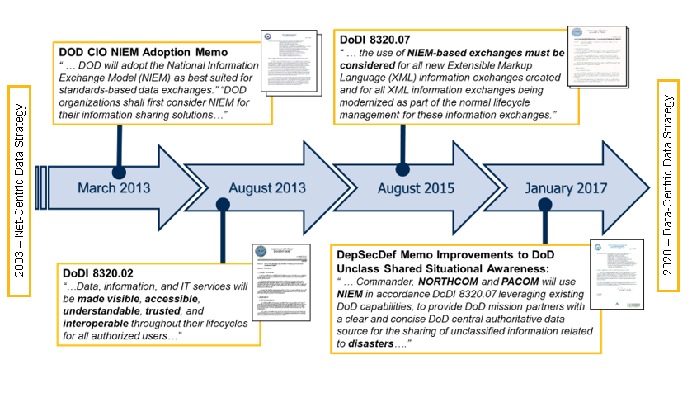

DoDI 8320.07: Directs consideration of “NIEM first” for new DoD data exchanges and is referenced in the following:​

* Army Regulation 25-1​ – Army Information Techology
* SecAF Manual 14-401 – Intelligence Analysis and Targeting Tradecraft/Data Standards
* SecAF Mission Directive 1-26​ – Chief Information Officer
* DCMA Manual 4502-15​ – Enterprise Data Governance
* MCO 5230.19A – Logistics Data Management​
* DoDI 1322.26​ – Distributed Learning
* DoDI 1312.01​ – DoD Occupational Information Collection and Reporting
* DoDI 6440.03 – DoD Laboratory Network​
* DoDI 8010.01​ – DoD Information Network Transport
* DoDI 8110.01​ – Mission Partners Environment Information Sharing Capability Implementation for the DoD
* DoDI 8260.03​ – The Global Force Management Data Initiative
* DoDI 8310.01​ – Information Technology Standards in the DoD
* DoDI 8320.05​ – Electromagnetic Spectrum Data Sharing
* DoDI 8330.01​ – Interoperability of Information Technology, Including National Security Systems
* DoDI 8420.02​ – DoD Satellite Communications
* DoDI 8500.01​ – Cybersecurity
* DoDI 8510.01​ – Risk Management Framework for DoD Systems

### Tactical Edge Interoperability & Standards Using NIEMOpen

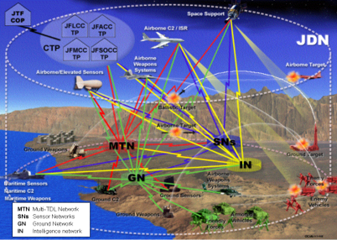

* DoD CIO / DISA / JESC Teamwork​​
* Data Technical Working Group (TWG)​​
* Country Code Working Group​​
* US Message Text Format Configuration Control Board​​
* Joint Symbology WG​​
* NATO​​
* CJADC2 to NATO Core Data Framework (NCDF) interoperability​
* US-NATO Military Messaging interoperability​​
* US-NATO Link 16 interoperability (+ FMS + FVEY +UK)​​
* HOD: Communications and Information Services Capability Panel​​
* Chair Data Management Capability Team (DM CaT)​​
* HOD: Data Management Syndicate (FMN)​​
* USA Rep: TDL XML Syndicate​​
* Lead: Link-22 Transactional Workshop (TWS)​​
* NATO Symbology Capability Team​​
* Operational SME: Tactical Data Link (TDL) and ​​
* Message Text Format (MTF), Data Centric Security (DCS)​ Capability Team (CaT)​​
* NIEM-conformant development​​
* MilStd 6016 (Link 16)​​
* All Domain Coordinated Time On Top Link 16 message​
* MilStd 6040 (Military Messaging MTF)​​
* MilStd 6017 (VMF)​​
* Various NATO data-related STANAGs (NCDF, Biometrics, etc.)​​
* Various Allied Procedural Publications (APP) for interoperability

​​

### Data Management Book of Knowledge (DMBOK) Reference

[DAMA International](https://dama.org/) is recognized as an organization pivtol in advancing data management practices. “Central to DAMA®'s contributions is the **Data Management Body of Knowledge (DAMA-DMBOK**®**)**, first published in 2009. This comprehensive guide offers best practices and a common vernacular for enterprise data management. The second edition, DAMA-DMBOK® 2, was released in 2017, with a revised edition in 2024, encompassing topics such as data architecture, security, quality, modeling, governance, big data, and data science.”[4]

An excerpt from the DAMA – DMBOCs speaks to NIEM.

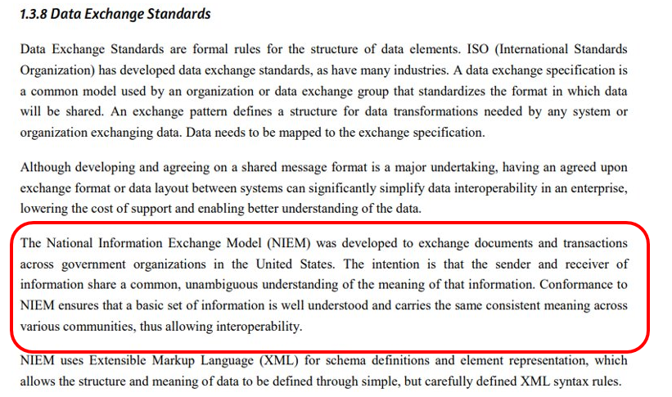

DAMA is in the process of updating the DMBOC. The Project Manager for this effort has reached out to NIEMOpen - OASIS t o discuss updating the next edition.

# Summary

The NIEM Open Project (NIEMOpen) is an evolution of the National Information Exchange Model (NIEM), which originated in 2003 from initiatives aimed at enhancing **data interoperability** across various sectors. Transitioning to a **community-driven approach** under the OASIS Open Projects Program, NIEMOpen emphasizes collaboration between the government and private sectors to establish standardized data frameworks. This initiative aims to streamline data sharing across diverse domains, which encompass critical areas such as national defense, justice, immigration, and emergency management. The project's architecture includes a common data model, known as NIEM core, and a methodology for creating Information Exchange Package Documentation (IEPD), now referred to as Message Exchange Packages (MEP), which facilitate the implementation of data exchanges.

NIEMOpen offers significant advantages by fostering **data standardization**, which enhances mutual understanding between different systems and organizations. This interoperability is crucial for mission success, particularly in contexts where distinct parties need to share information seamlessly. The project not only provides a technical framework for defining data structures but also offers tools that support the development, validation, and documentation of information exchanges. As a result, NIEMOpen has become a valuable resource for over 20,000 data elements utilized by federal, state, and local agencies, as well as international partners and industry, enhancing their capability to exchange information effectively.

In conclusion, NIEMOpen represents a pivotal advancement in data sharing and interoperability efforts across multiple sectors. Its community-driven nature and collaboration with OASIS facilitate the creation of reliable data standards that meet the needs of diverse agencies. By establishing NIEMOpen as an accredited open-source standard, the project not only enhances **data interoperability** but also sets the foundation for future innovations in information exchange, potentially leading to ANSI and ISO standardization. This ongoing evolution underscores the importance of collaborative efforts in addressing the complexities of modern data sharing and governance.

# Acronyms

A

ANSI American National Standards Institute

API Application Programming Interface

C

CDC Center for Disease Control

CMF Common Model Format

D

DoD Department of Defense

DoJ Department of Justice

DHS Department of Homeland Security

ESC Executive Steering Council

G

GJXDM Global Justice XML Data Model

H

HHS Health and Human Services

I

IEPD Information Exchange Package Documentation

ISO International Standards Organization

J

JSON Java Script Object Notation

JSON-LD Java Script Object Notation for Linked Data

M

MEP Message Exchange Package

N

NBAC NIEMOpen Business Architecture Committee

NDR Naming and Design Rules

NGO Non-Governmental Organization

NIEM National Information Exchange Model former acronym prior to transition to OASIS in 2022

NIEM NIEMOpen Project brand name when referencing data model, architecture, technical infrastructure, and domain spaces

NIEMOpen NIEM Open Project

NMO NIEMOpen Management Office

NTAC NIEMOpen Technical Architecture Committee

O

OASIS Organization for the Advancement of Information Standards

P

PS02 Project Specification 02

PSD01 Project Specification 01

PVO Private Voluntary Organization

PGB Project Governing Board

R

RDF Resource Description Framework

T

TSC Technical Steering Committee

X

XML Extensible Markup Language

XSD XML Schema Definition

# Endnotes

1. XSD - **XML Schema Definition (XSD)** is a powerful language used to describe the structure and constraints of XML documents. XSD defines the legal building blocks of an XML document, including elements, attributes, and their data types. It ensures that the XML document is both well-formed and valid. A well-formed XML document follows the basic syntax rules of XML, while a valid XML document adheres to the rules defined in the XSD; [XML Schema Tutorial](https://www.w3schools.com/xml/schema_intro.asp) .
2. RDF - RDF stands for **Resource Description Framework** and is a standard for describing web resources and data interchange, developed and standardized with the World Wide Web Consortium (W3C). RDF is a standard way to make statements about resources. An RDF statement consists of three components, referred to as a *triple*; [XML RDF](https://www.w3schools.com/XML/xml_rdf.asp) .
3. JSON/JSON-LD -JSON stands for **JavaScript Object Notation**. JSON is a lightweight format for storing and transporting data. Data is in name/value pairs, data is separated by commas, curly braces hold objects, and square brackets hold arrays. The JSON syntax is derived from JavaScript object notation syntax, but the JSON format is text only. Code for reading and generating JSON data can be written in any programming language. J**SON-LD** **(JavaScript Object Notation for Linked Data)** is a method of encoding linked data using JSON. It allows data to be serialized in a way that is similar to traditional JSON, making it easy for developers to transform their existing JSON to JSON-LD with minimal effort.; [JSON-LD 1.1](https://www.w3.org/TR/json-ld11/) .
4. <https://dama.org/about-dama/who-we-are/> .